# Ass04_techDemo

I combined the tasks from Ass03_spaceShooter (t10 assessment) and Ass04_techDemo (t11 assessment) assessments.

**From Ass03_spaceShooter**

* There is an Intro Mode, PlayMode and GameOverMode
* Parallax scrolling
* I implemented ship control and shooting using a gamepad.
* Player scores 10 for destroying an asteroid.
* The player can shoot the asteroid.
* Ship exhaust and rocket animate.

**From Ass04_techDemo**

* Intro, Play/Game, and GameOver mode.
* Added an asteroid.
* The player ship flies around using either keyboard or a gamepad.
* Added menu mode.

**GAME STATE FLOWCHART**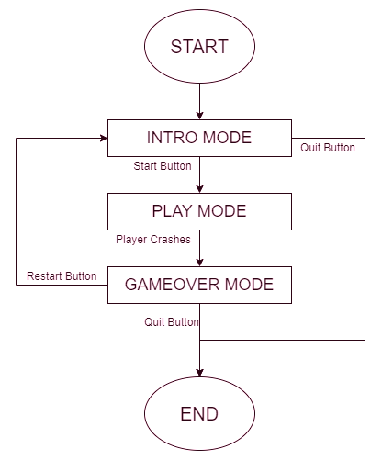

**TEST PLAN**

|  |  |  |  |
| --- | --- | --- | --- |
| INPUT | ACTION | RESULTS | |
| **Expected** | **Results** |
| Left Mouse Button | Activates the button that is placed | Activate the button’s action, i.e. the quit button closes the game window | Activated the button’s action |
| Up Arrow  Key  Or  Controller(0), LeftStick.Up | Move the Player’s ship up | The Player’s ship moves upwards | The Player’s ship moved upwards |
| Down Arrow  Key  Or  Controller(0) -> LeftStick.Down | Move the Player’s ship down | The Player’s ship moves downwards | The Player’s ship moved downwards |
| Left Arrow  Key  Or  Controller(0) -> LeftStick.Left | Move the Player’s ship towards the left | The Player’s ship moves towards the left | The Player’s ship moved towards the left |
| Right Arrow  Key  Or  Controller(0) -> LeftStick.Right | Move the Player’s ship towards the right | The Player’s ship moves towards the right | The Player’s ship moved towards the right |
| Combined Keys  Or  Controller(0) -> LeftStick Diagonal movement | Move the Player’s ship in diagonal directions | The Player’s ship moves in diagonal directions | The Player’s ship moved in diagonal directions |
| Space key  Or  Controller(0) -> xinput_Gamepad_A button | Shoot the missiles from the Player’s ship | Shoot missiles from the Player’s ship | Shot missiles from the Player’s ship |